- ACADEMIA - EDITORIAL

Free Ba’asyir? Why now?
- Editorial Board
The Jakarta Post
Jakarta / Mon, January 21, 2019 / 08:34 am
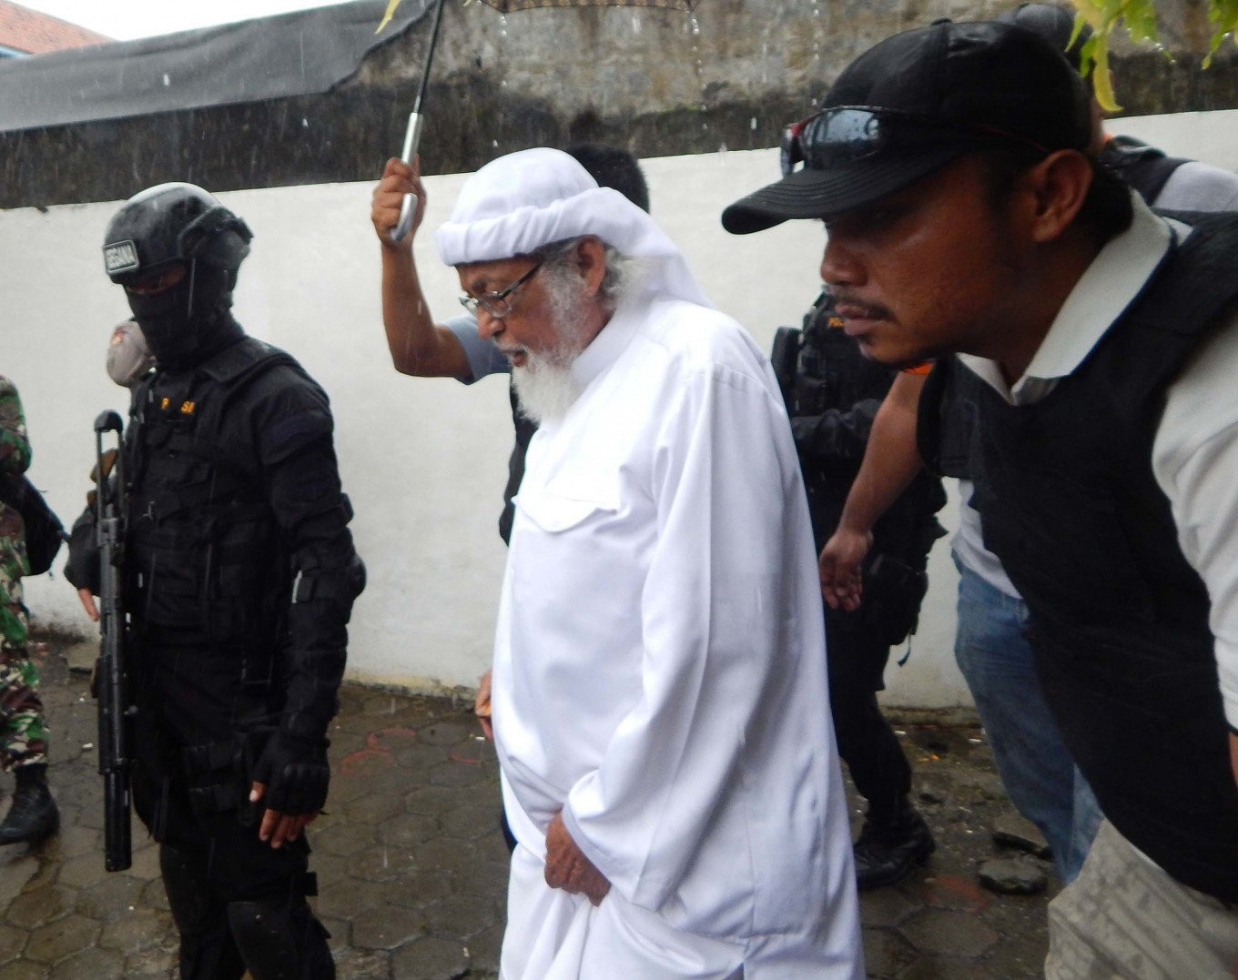
Police officers escort terrorism convict Abu Bakar Ba'asyir to the Cilacap District Court in Central Java for a hearing on his case review. (thejakartapost.com/Agus Maryono )

491
SHARES

There is nothing wrong with granting an old and ailing felon conditional release or even a pardon on humanitarian grounds. But President Joko “Jokowi” Widodo’s decision to approve the early release of 81-year-old terror convict and firebrand cleric Abu Bakar Ba’asyir is wrong on so many levels.
It is not impossible to pardon the ailing cleric on humanitarian grounds, but the timing and circumstances of the President’s decision are so suspicious that one wonders whether his health condition was a factor at all.
The call came only months before the April presidential election in which Jokowi will square off against his old rival, Prabowo Subianto, in a bid to secure a second term.
Prabowo has been touted as the more Islamic candidate by hardline Islamists, while Jokowi is struggling to convince voters he is not a communist, even after naming the leader of the nation’s most influential Islamic institution as his running mate.
Given the political backdrop, it is too easy to believe the move was just another attempt by Jokowi to win Muslim votes.
Yusril Ihza Mahendra, the lawyer for the Jokowi-Ma’ruf Amin campaign, has dismissed such speculation. Mahendradatta, Ba’asyir’s lawyer, has also claimed that his client’s release has nothing to do with politics, that it is not a “political gift” from Jokowi. The claim is hardly convincing. Ba’asyir’s lawyers had long cited Ba’asyir’s deteriorating health as the primary reason for his release, or him being put under house arrest. The government had ignored the request. So why the change now?
Moreover, the Jokowi administration has been far from transparent in explaining the legal basis for Ba’asyir’s release.
Days after the decision was made public, officials said it was unclear if Ba’asyir was pardoned or granted conditional release. It is hard to say which.
Neither the cleric nor his lawyer have ever sought presidential pardon. The cleric is neither eligible for conditional release, despite having served two thirds of his prison sentence, because he refused to sign a letter of loyalty to the state ideology Pancasila — a requirement for all terror convicts.
Yusril argued Jokowi could just change or “ignore” the policy, as it is only stipulated in a ministerial regulation, not a law. While it is possible to tweak the regulation, one wonders why Jokowi needs to go through all that for Ba’asyir.
This leads to another issue: fairness.
The President has often pledged to not interfere with the law. Only recently, Jokowi cited the exact argument to reject calls for him to grant clemency to a housewife jailed for inadvertently exposing the man accused of sexually abusing her.
Jokowi is also merciless to drug convicts. Last July, a terminally ill Pakistani drug convict on death row died in prison. The man claimed innocence and Jokowi refused to free him despite his health condition and plea for justice.
The President has the prerogative to pardon convicts, but he is obliged to justify his action before citizens. His decision on Ba’asyir was poorly timed, legally flawed and insensitive. It sent all the wrong messages to many of his supporters as well as the international community.

Source: https://www.thejakartapost.com/academia/2019/01/21/free-baasyir-why-now.html

- ACADEMIA - OPINION

Our double standards on Jerusalem and Ba’asyir
- Kornelius Purba
The Jakarta Post
Jakarta / Wed, January 23, 2019 / 09:07 am
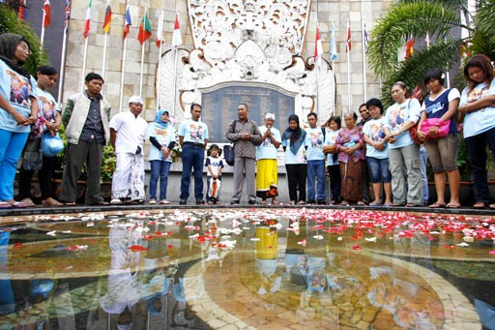
The deaths of 202 people in a terrorist attack are commemorated by friends and family at the Bali Bombing monument in Kuta, Bali, on Oct. 12, 2010. (JP/Stanny Angga)

441
SHARES

Right or wrong, Indonesia is always right no matter what. How about other nations? It totally depends on our own judgement. Other nations must always readjust themselves to our position. Indonesia strongly protested Australia’s intention to relocate its embassy to Jerusalem last year and even threatened to drop a crucial economic deal between the two countries unless Australia retracted its intention. But is that not a blatant violation of our neighbor’s sovereignty?
“Indonesia conveys our strong concern on the announcement and questions the merit of the announcement,” Foreign Minister Retno LP Marsudi said on the issue in a joint press briefing with visiting Palestinian counterpart Riyad al-Maliki last October.
It seems only Indonesia has the prerogative to protest the decisions of other sovereign countries. Witness our reaction to Australia, which protested the planned release of a spiritual leader infamous for his influence on terrorists. We ignored the feeling of Australians who lost 88 citizens in the Oct. 12, 2002, terrorist attack in Bali. Neither do we care how they must still be traumatized over the bombing attack on their embassy in Jakarta on Sept. 9, 2004.
The planned released of cleric Abu Bakar Ba’asyir “is our domestic affair”, said the inactive chairman of the Indonesian Ulema Council, Ma’ruf Amin, who is also President Joko “Jokowi” Widodo’s running mate in April’s presidential election.
“Does Australia think they control us?” Coordinating Maritime Affairs Minister Luhut Pandjaitan said after Australian Prime Minister Scott Morrison telephoned Jokowi to express his government’s position against the plan to release Ba’asyir from prison for humanitarian reasons. Vice President Jusuf Kalla echoed Ma’aruf and Luhut’s sentiments on Tuesday, while officials are backtracking on the controversial plan.
Indonesians tend to think our beloved country is the center of the world. We often judge other people based on own our values or religious interpretations. When others express different views about our culture, religion and systems we tend to be defensive, if not angry, and accuse them of being infidels or blasphemous.
Morrison promised to consider relocating the Australian Embassy from Tel Aviv to Jerusalem during the election campaign last October, following in the footsteps of United States President Donald Trump. As indicated by Retno, Jokowi conveyed his strong objection to the plan in a telephone call with Morrison.
Indonesia insisted that the embassy’s relocation would hurt the feelings of mostly Muslim Indonesians and other predominantly Muslim nations. Reports said Indonesia threatened to indefinitely delay signing the Indonesia-Australia Comprehensive Economic Partnership Agreement. As if the agreement just serves the interest of Australia.
“Indonesia has asked Australia and other countries to keep supporting the Palestine-Israel peace process in accordance with the principles that have been previously agreed upon, and not the action that could threaten the peace process itself and global security,” Retno warned Australia.
Indonesian protesters threatened to occupy the Australian Embassy in Jakarta unless Canberra retracted its Jerusalem relocation policy. Even when presidential candidate Prabowo Subianto rightly said the issue was within Australia’s sovoreignity, his supporters were angry.
“[…] as the supporters of Palestine, we certainly have our own opinions. But Australia is an independent and sovereign country, we must respect their sovereignty,” said Prabowo who is running against Jokowi in April.
The subject of the latest controversy, Ba’asyir, who is the convicted spiritual leader of terror group Jamaah Islamiyah, was imprisoned for two-and-a-half years for being the mastermind behind the 2005 Bali bombing. However, he was acquitted by the Supreme Court in 2006. In 2011, he was sentenced to 15 years in prison for supporting a jihadi military training camp in Aceh.
“I am considering his health, especially his access to medical services,” Jokowi said over the weekend when asked about his reasons of the planned release. “The main concern is humanitarian reasons. He is old,” he explained on Friday.
Citing legal obstacles, his own Cabinet members have expresed reservations about the plan. But we do not need to ask a genius to support public suspicion that Jokowi’s plan is strongly related to his ambition to defeat Prabowo again in their rematch.
We strictly stick to noninterference in our domestic affairs when we dislike other people’s concerns. Yet, we always condemn the execution of Indonesian convicts in other countries such as Saudi Arabia and proudly shout out the government’s success in saving Indonesians from the death penalty. And when other countries protest the execution of their citizens, the government simply answers, “It’s none of your business.”
But will Jokowi listen to the tearful protests of the families of those butchered by the terrorists in Bali and in other places in Indonesia?
Jokowi, this is not just our domestic issue. This is a universal concern. Many predict you will easily win the presidential election in April. Please make a decision after listening to your own conscience and not just to ensure your political victory. It is not just you; the whole nation will pay dearly for any blunder you make now.

Source: https://www.thejakartapost.com/academia/2019/01/23/our-double-standards-on-jerusalem-and-baasyir.html

- ACADEMIA OPINION

Questioning early release of Ba'asyir
- Carrisa Tehputri
Abu Dhabi / Tue, January 22, 2019 / 11:38 am
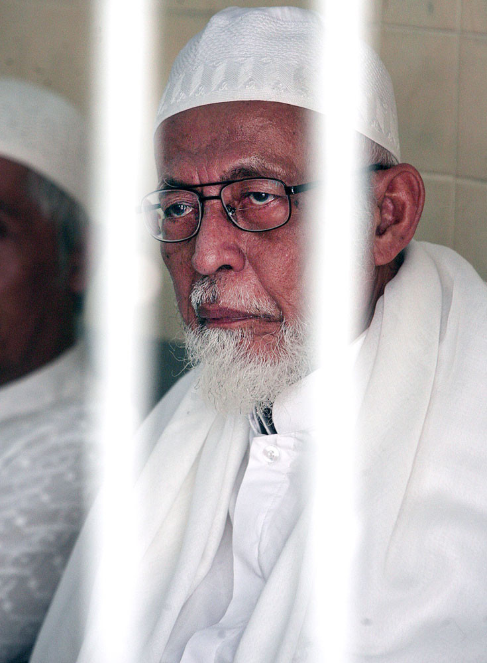
Abu Bakar Ba’asyir (The Jakarta Post/R. Berto Wedhatama)

332
SHARES
President Joko “Jokowi” Widodo has ordered the Law and Human Rights Ministry to prepare for the early release of Abu Bakar Ba’asyir for “humanitarian reasons”, taking into account his age and deteriorating health.
This decision has surprised many, considering Ba’asyir is notorious for his repeated involvement in terrorism and his endorsement of radical Islam. Significantly, the United Nations placed him on its list of international terrorists.
He is known to be the spiritual leader of Jamaah Islamiyah, which was responsible for several terrorist attacks and assassinations in Southeast Asia and is linked to other terrorist groups such as al-Qaeda and the Moro Islamic Liberation Front.
In Indonesia, Ba’asyir himself is well known as the mastermind of the 2002 Bali bombing, an attack so grave it attracted overwhelming international attention.
The attack not only killed and injured more than 400 people, it also destroyed the livelihoods of millions of Balinese as a result of travel bans and the deteriorating state of tourism there.
Ba’asyir was actually offered parole in 2018 on condition that he would declare loyalty to Pancasila and vow not to repeat his crimes, compulsory requirements for inmates convicted of terrorism charges according to the regulation.
Insisting on his innocence and his belief that Pancasila is against Islam, he refused the offer. In contradiction of the importance of those two requirements, a few months later he was offered this unconditional release based on compassion and humanitarian reasons.
Now the question is: Is his compassionate release really justifiable, considering the gravity of his crime and the repetitive nature of his actions and taking into account that over the years his support for radical Islam never faded?
Ba’asyir has openly refused to declare his allegiance to Pancasila and Indonesia and, in fact, in July 2014 he publicly declared his allegiance to Abu Bakr Al Baghdadi, the leader of the Islamic State movement, and his support for a caliphate.
Despite his notoriety for his repeated crimes, Ba’asyir had his sentence reduced.
In 2003, he was sentenced to three years in prison for immigration violations possibly related to terrorism, but the sentence was reduced to 20 months because of good behavior.
In October 2005, he was found guilty of involvement in the 2002 Bali bombing and was sentenced to two and half years of imprisonment, but this was eventually cut by four months and 15 days.
After his release in 2006 he pledged himself to a campaign to impose sharia. In October 2008, Ba’asyir also announced his intention to start Jamaah Ansharut Tauhid, a new Islamic group in Indonesia, which was later put in the United States terrorism list.
In December 2010, Ba’asyir was again arrested and charged with involvement in plans for terrorist actions and military training in Aceh.
He was convicted in June 2011 for supporting a terrorist training camp and was sentenced to 15 years in prison.
His repeated imprisonment does not represent good behavior or a promising future in which he would at least not pose a threat to the larger society. His persistence over the years only proves to us that his allegiance to radicalism has never died and the fact that he is currently more than 80 years old would not change that.
Ideology doesn’t age the same way the body does; it never dies.
Furthermore, if deteriorating health and old age are really the reasons, do more than 4,000 other elderly inmates aged 65 years and older in Indonesia stand the same chance? Are they also to receive early compassionate release, or are their cases to be forgotten because they are just anonymous, unknown inmates in the system?
Is it really fair to release one inmate who has such a long and dangerous track record, but to keep 4,000 others incarcerated, regardless of their health conditions and the fact that their days are also numbered?
The law is supposed to be fair and universal. Everyone is equal before the law, according to the Constitution.
While Ba’asyir is getting his early release, Meiliana, a woman from North Sumatra, is serving 18 months’ imprisonment for merely complaining to her neighbor that the adzan (call to prayers) from her local mosque was too loud.
Likewise, crosses are broken in graveyards, Ahmadi mosques and Buddhist viharas are burned to ashes and Javanese new year offerings are destroyed, but the President remains silent.
***
Source:
https://www.thejakartapost.com/academia/2019/01/22/questioning-early-release-of-baasyir.html

